MINI PROJECT

(SESSION-2019-2020)

Report



**Institute of Engineering & Technology**

**Team Members**

**ABHISHEK GUPTA**

**(181500017)**

**ANUSHKA MAHESHWARI**

**(181500124)**

**AKANSHA GUPTA**

**(181500053)**

## Supervised By

**MR. ANAND GUPTA**

**TECHNICAL TRAINER**

**Department of Computer Engineering &Websites**



**Department of Computer Engineering and Applications**

**GLA University, Mathura**

**17 km. Stone NH#2, Mathura-Delhi Road, P.O. – Chaumuha,**

**Mathura – 281406**

**Declaration**

I hereby declare that the work which is being presented in the Mini Project **“E-Shiksha”,** in partial fulfillment of the requirements for Mini project Lab is an authentic record of our own work carried under the supervision of **Mr. Anand Gupta, Technical Trainer.**

**Abhishek Gupta**

**Anushka Maheshwari**

**Akansha Gupta**



**Department of Computer Engineering and Applications**

**GLA University, Mathura**

**17 km. Stone NH#2, Mathura-Delhi Road, P.O. – Chaumuha,**

**Mathura – 281406**

**Certificate**

This is to certify that the project entitled “E-Shiksha” carried out in Mini Project – II Lab is a Bonafede work done by Abhishek Gupta (181500017), Akansha GUPTA (181500053), Anushka Maheshwari (181500124) and is submitted in partial fulfillment of the requirements for the award of the degree Bachelor of Technology (Computer Science & Engineering).

**Signature of Supervisor:**

**Name of Supervisor: Mr. Anand Gupta**

**Date:20/04/2021**

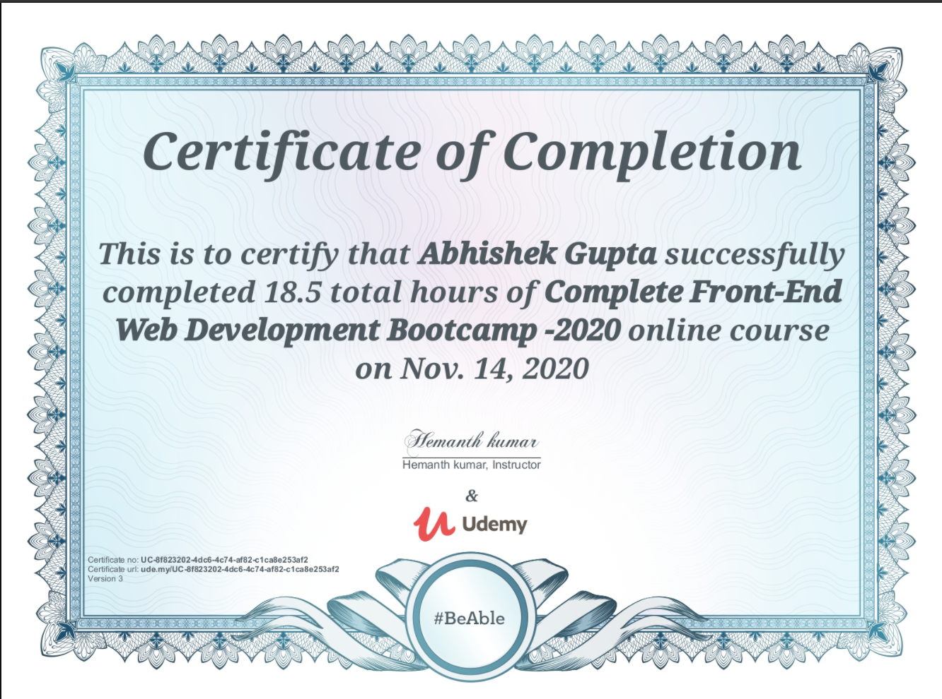

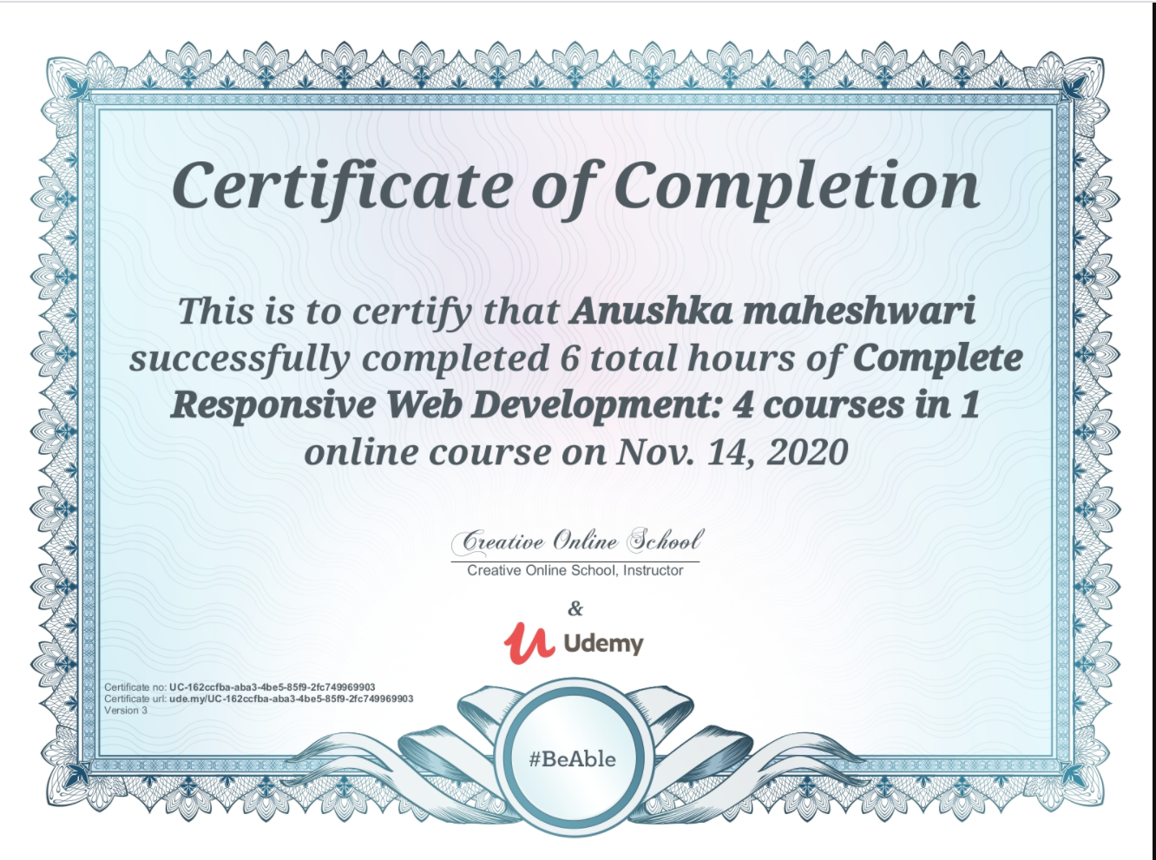

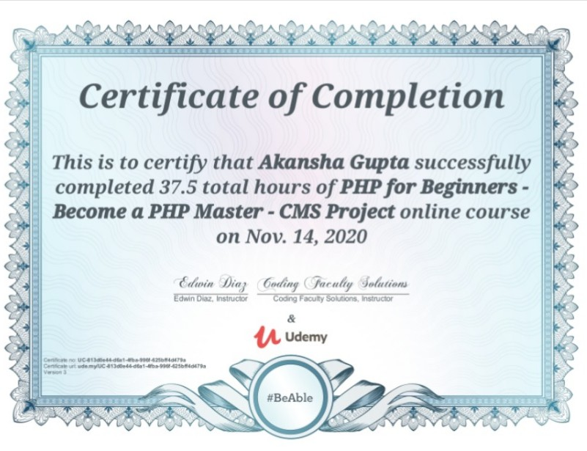

**ACKNOWLEDGEMENT**

It gives us a great sense of pleasure to present the report of the B. Tech Mini Project undertaken during B. Tech. Third Year. This project in itself is an acknowledgement to the inspiration, drive and technical assistance contributed to it by many individuals. This project would never have seen the light of the day without the help and guidance that we have received.

Our heartiest thanks to Dr. (Prof). Anand Singh Jalal, Head of Dept., Department of CEA for providing us with an encouraging platform to develop this project, which thus helped us in shaping our abilities towards a constructive goal.

We owe special debt of gratitude to Mr. Anand Gupta, Technical Trainer, for his constant support and guidance throughout the course of our work. His sincerity, thoroughness and perseverance have been a constant source of inspiration for us. He has showered us with all his extensively experienced ideas and insightful comments at virtually all stages of the project & has also taught us about the latest industry-oriented technologies.

We also do not like to miss the opportunity to acknowledge the contribution of all faculty members of the department for their kind guidance and cooperation during the development of our project. Last but not the least, we acknowledge our friends for their contribution in the completion of the project.

**ABHISHEK GUPTA**

**AKANSHA GUPTA**

**ANUSHKA MAHESHWARI**

**Abstract:**

E- shikha (E-Learning Management System) is a project which aims in developing an online application to provide Online Education, maintain Study Materials, keep Student records and collect Payments. This project has login features, Educator as Admin and Student as a user can login into their own portal separately. The Admin can login, through which the admin can monitor the whole system. This System can be used to search for course, add new courses, edit course, check payment status etc. The Admin after logging into his account can generate reports such as sell Report. The User can login into his account to follow course he purchased and can share his/her feedback.

Overall this project of ours is being developed to help the Educator (Admin) as well as Students (User) to provide Teaching-Learning platform in the best way possible.

**Table of Contents**

|  |  |
| --- | --- |
| Declaration | 2 |
| Certificate | 3 |
| Acknowledgments | 7 |
| Abstract | 8 |
| Table of Contents | 9 |
| Introduction | 10  \ |
| Requirements | 12 |
| Data Flow Diagram | 14 |
| ER Diagram | 16 |
| Flow Chart | 17 |
| Problem & Challenges | 18 |
| Objectives | 19 |
| Implementation Details | 20 |
| Design | 23 |
| Input/Output Modules | 24 |
| Module & their Description | 25 |
| System Flow Diagram | 27 |
| Snaps | 28 |
| Code | 36 |
| Limitation of Project | 56 |
| References | 56 |
|  |  |

**Introduction:**

It is difficult to find time for the training necessary to gain new skills and boost your productivity. With E-Shiksha you’re able to learn at a pace that is comfortable for you. E-Shiksha is a powerful Learning Management System implementing the latest trends in e-learning. E-Learning is learning utilizing electronic technologies to access educational curriculum outside of a traditional classroom. In most cases, it refers to a course, or program delivered completely online. We define eLearning as courses that are specifically delivered via the internet to somewhere other than the classroom where the professor is teaching. E-Learning has been proven to be a successful method of training and education is becoming a way of life for many citizens in India and across the World. E-Shiksha Publisher is a professional team development environment for the rapid development of e-courses by their own. Any Person who wants to gain new skills can join E-Shiksha. A Person/Student/Learner has to fill up registration form which is absolutely free. Once Learner registers successfully, they will get User ID /Email and Password for login into Student/Learner Panel. After login they can buy any course as per their choice or requirement which is available in E-Shiksha. They can watch purchased video courses online and can submit their feedback. As well they can update their profile and can change password. Admin of this system will upload new courses which will be available for everyone. Admin can delete or edit student/learner details. Admin can modify course details and can check sells report.

**General Introduction to the topic**

It is difficult to find time for the training necessary to gain new skills and boost your productivity. With E-Shiksha you’re able to learn at a pace that is comfortable for you. E-Shiksha is a powerful Learning Management System implementing the latest trends in e-learning. E-Learning is learning utilizing electronic technologies to access educational curriculum outside of a traditional classroom. In most cases, it refers to a course, or program delivered completely online. We define eLearning as courses that are specifically delivered via the internet to somewhere other than the classroom where the professor is teaching. E-Learning has been proven to be a successful method of training and education is becoming a way of life for many citizens in India and across the World. E-Shiksha Publisher is a professional team development environment for the rapid development of e-courses by their own.

**EXISTING SYSTEM:**

For E-Shiksha there are some online services and more offline services are there, offline education systems are working with papers work from different locations. Even education platform is teaching manually their students .so it difficult to keep all manage students doubts and their problems. Current system all work is done manually and it is so difficult to manage the data manually.to make teaching effective and online a new computer-based application is required.

**Area of Computer Science:**

This project as titled “E-Shiksha (E-Learning Management System)” is comes under the Web Based Application.

This application is developed with the help of HTML, CSS, Bootstrap, PHP, MySQL etc.

**Hardware Requirements:**

|  |  |
| --- | --- |
| Processor | 1.6 GHz or Faster Processor |
| RAM | 4 GB |
| Disk Space | 10 GB of Available Hard Disk |
| Graphic | DirectX 9-Capable Video Card |
| Display | 1024 X 768 or Higher Resolution |

**Software requirements:**

|  |  |
| --- | --- |
| Operating System | Windows 10 |
| Front End | HTML, CSS, JavaScript |
| Back End | PHP |
| Library/ Framework | Bootstrap, JQuery, FontAwesome |
| Plugins | Owl Carousel |
| Code Editor | Visual Studio Code 1.33 |
| Database | MySQL |
| Web Server | Apache |
| Web Browser | Google Chrome |
| Drawing Tools | yEd Graph Editor |

**Reasons of using PHP and MySQL:**

**1. PHP:**

PHP is an open source language and all its components are free to use and distribute. PHP is server-side scripting language. It is embedded in HTML source code. PHP supports all major web servers such as Apache, Microsoft IIS and Netscape etc. All the major database such as MySQL, PostgreSQL, Oracle, Sybase, Microsoft SQL Server is supported by PHP.

Following are some major advantage: -

* Friendly with HTML - PHP and HTML are interchangeable within the page. You can put PHP outside the HTML or inside.
* Interactive Features - PHP allows you to interact with your visitors in ways HTML alone can't.
* Top-Notch Online Documentation - The PHP documentation is the best on the web. Hands down.
* Compatible with Databases - A good benefit of using PHP is that it can interact with many different database languages including MySQL.

**2.MySQl:**

MySQL is the most popular open source relational database management system. It is one of the best RDBMS being used to develop web-based applications. It is easy to use and fast RDBMS.

Following are the top reason to use MySQL: -

* + High Performance
  + Robust Transactional Support
  + Strong Data Protection

• Open Source Freedom

**Data Flow Diagram:**

Data flow diagram is graphical representation of flow of data in an information system. It uses defined symbols Like rectangles, circles and arrows, plus short text labels, to show data inputs, outputs, storage points and the routes between each destination.

**1. DFD 0 Level:**

The 0 Level DFD shows flow of data of application. DFD Level 0 is also called a Context Diagram. It’s a basic overview of the whole system or process being analyzed or modeled.

E

-

shiksha

E

(

-

learning

management system)

Admin

Student/learner

Report

Upload

course

watch course

Buy course

**2.DFD 1 Level:**

DFD Level 1 provides a more detailed breakout of pieces of the Context Level Diagram. This DFD describes main functions carried out by the system, as we break down the high-level process of the Context Diagram into its sub-processes.

Authentic

Admin

Admin/Student

student

Update

profile

Authentic status

student

retrieve

update

Up

load course

Authentic status

course

retrieve

update

Update lesson

lesson

retrieve

update

Authentic status

logout

Authentic status

**Entity Relationship Diagram (ER-Diagram):**

An Entity Relationship Diagram (ERD) is a visual representation of different entities within a system and how they relate to each other.

LESSON_ID#

LESSON_NAME

LESSON_DESC

LESSON_LINK

COURSE_ID

COURSE_NAME

LESSON

has

s

COURSE_ID#

COURSE_NAME

COURSE_DESC

COURSE_IMG

COURSE_PRICE

COURSE_DUR

COURSE

add

d

ADMIN_ID#

ADMIN_EMA

IL

ADMIN_NAM

E

ADMIN_PASS

ADMIN

a

d

d

has

STU_ID#

STU_NAME

STU_EMAIL

STU_PASS

STU_OCC

STU_IMG

STUDENT

add

F_ID#

F_CONTENT

STU_ID

FEEDBACK

watch

order

CO_ID#

ORDER_ID

STU_EMAIL

COURSE_ID

STATUS

RESPMSG

AMOUNT

ORDER_DATE

COURSE ORDER

**Flow Chart:**

A flowchart is a diagram that depicts a process, system or computer algorithm. They are widely used in multiple fields to document, study, plan, improve and communicate often complex processes in clear, easy-to-understand diagrams.

START

ENTER USERNAME

PASSWORD

IS INPUT

VALID

?

INAVLID

USERNAME AND

PASSWORD

DASHBOARD

STOP

**Problems & Challenges**

There were certain issues that were highlighted:

* The lack of learners’ motivation:

One of the most common eLearning challenges that eLearning professionals must overcome is an overall lack Of learner motivation. It might stem from learners who aren't enthusiastic about the content or aren't interested in the subject matter. To overcome this hurdle, it's important to make the eLearning course.

* The busy schedules of the learners:

In this day-and-age, it seems that everyone is running short on time. There aren't enough hours in the day, and there isn't any room in the schedule for learning. Many people are hesitant to take an eLearning course because they think that they won't be able to go at their own pace or that it will require a great deal of their time.

* The belief that learners should be tech savvy:

Not all of the learners are going to have the latest and greatest tech gadgets, nor all learners are going to be “tech savvy”. And the truth is that there is no reason to be! This perception is yet another eLearning Challenge. However, this can be overcome by ensuring that your eLearning course is available on a wide range of devices and platforms, and that it is in fact easy to navigate.

* The belief that eLearning offers no support:

It is a general misconception that eLearning courses offer no support for their learners. In fact, this belief prevents many individuals from enrolling, even if they are highly motivated to learn and have the time to do so. To overcome this eLearning challenge, be sure to have a solid support system in place for all of your learners.

* Learners can't see the real-world implications of the eLearning course:

Sometimes a learner is not able to see the value or benefit of the eLearning course, and especially how the subject matter is going to help him/her in the real world.

.

**Objectives**

A flexible web-based learning experience allows you to go through a guided curriculum or choose lessons on a Needed basis.

Following are the main objectives: -

* Ability to recall previously learned material – Students/learners can watch video courses as many times as they need. If they forgot something during the course they can come back and watch that specific part anytime.
* Creative way to present lesson – It is very creative way to present lectures. It will surely enhance teaching ability of tutor.
* Low Cost – As nobody needs to travel or rent anything so it’s very cost efficient.
* High Quality – As tutor do not has time foundation so he can teach in his own comfort time.
* Learn anytime from anywhere – Students/Learners can start learning anytime from anywhere they just required internet connection with a compatible device.
* Improve course quality according to learner’s feedback – Tutor can improve their course as per student’s feedback. It will help tutor to improve their ability to teach.
* Earn Money Online– As courses are paid so we can say it’s an online teaching business which has no boundaries means students/learners can join from across the world so this system can make good business with good quality

**Implementation Details**

**Technical Feasibility:**

The proposed system is developed using HTML, CSS and bootstrap as front-end tool and php and js node as The back end. The proposed system needs a Personal Web Server to serve the requests submitted by the users. The Web browser is used to view the web page that is available within the Windows operating system itself. The proposed system will run under Win9x, NT, and win2000 environment. As Windows is very user friendly and GUI OS it is very easy to use. All the required hardware and software are readily available in the market. Hence the system is technically feasible.

**Operational Feasibility:**

The proposed system is operationally feasible because of the following reasons: The customer is benefited more as most of his time is saved. The customer is serviced at his place of work. The purpose of this website serves the good and needy people.

**Economic Feasibility:**

As the necessary hardware and software are available in the market at a low cost, the initial investment is the only cost incurred and does not need any further enhancements. Hence it is economically feasible.

The system is feasible in all respects and hence it encourages taking up the system design.

We have used different languages and technologies for preparing the project. These are described below:

**HTML:**

The extended reach of information and services to customers that the Internet has enabled, has created a new challenge for the developer. The developer should develop a user interface that is distributable, available on multiple platforms and supports a wide range of client environments from handheld wireless devices to high-end workstations. So to maintain a broad reach to client environments and to achieve greatest compatibility with all browsers, this system uses standard HTML.

Hyper Text Markup Language is the standard language for creating documents for the World Wide Web. An HTML document is a text file, which contains the elements, in the form of tags that a web browser uses to display text, multimedia objects, and hyperlinks using HTML; we can format a document for display and add hyperlinks to other documents.

The user interface has been designed in HTML hence can be browsed in any web browser.

**Cascading Style Sheets:**

These have been used to separate data form presentation. By using these style sheets throughout the project, a uniform look and feel can be maintained for all the HTML elements and tags that have been used in the project.

If there is any revamp the way the content has been presented in the website, the changes can be made to the Appropriate style sheet, which will be reflected across all the style sheets.

**Bootstrap:**

Bootstrap is a web framework that focuses on simplifying the development of informative web pages (as oppose[d to web apps). T](https://en.wikipedia.org/wiki/Web_Apps)he primary purpose of adding it to a web project is to apply Bootstrap's choices of color, size, font and layout to that project. As such, the primary factor is whether the developers in charge find those choices to their liking. Once added to a project, Bootstrap provides basic style definitions for all [HTML elements. Th](https://en.wikipedia.org/wiki/HTML_element)e result is a uniform appearance for prose, tables and form elements across [web browsers](https://en.wikipedia.org/wiki/Web_browser). [In](https://en.wikipedia.org/wiki/Web_browser) addition, developers can take advantage of CSS classes defined in Bootstrap to further customize the appearance of their contents. For example, Bootstrap has provisioned for light- and dark colored tables, page headings, more prominent pull quotes, and text with a highlight.

Bootstrap also comes with several JavaScript components in the form of query [plu](https://en.wikipedia.org/wiki/JQuery)gins. They provide additional user interface elements such as [dialog boxes,](https://en.wikipedia.org/wiki/Dialog_box) [tooltips, an](https://en.wikipedia.org/wiki/Tooltip)d carousels. Each Bootstrap component consists of an HTML structure, CSS declarations, and in some cases accompanying JavaScript code. They also extend the functionality of some existing interface elements, including for example an auto-complete function for input fields.

**PHP:**

**PHP** is a [general-purpo](https://en.wikipedia.org/wiki/General-purpose_programming_language)[se scripting language esp](https://en.wikipedia.org/wiki/Scripting_language)ecially suited to [web development. It](https://en.wikipedia.org/wiki/Web_development) was originally created by Danish-Canadian [programm](https://en.wikipedia.org/wiki/Programmer)[er Rasmus Lerdorf in 1](https://en.wikipedia.org/wiki/Rasmus_Lerdorf)994; the PHP [reference implementation is](https://en.wikipedia.org/wiki/Reference_implementation) now produced by the PHP Group. PHP originally stood for *Personal Home Page*, but it now stands for the [recursive initialism](https://en.wikipedia.org/wiki/Recursive_initialism) PHP code is usually processed on a [web server by a](https://en.wikipedia.org/wiki/Web_server) PHP [interpreter imp](https://en.wikipedia.org/wiki/Interpreter_(computing))lemented as a [module,](https://en.wikipedia.org/wiki/Plugin_(computing)) [a daemon](https://en.wikipedia.org/wiki/Daemon_(computing)) or as a  [Common Gateway Interface (CG](https://en.wikipedia.org/wiki/Common_Gateway_Interface)I) executable. On a web server, the result of the interpreted and executed PHP code – which may be any type of data, such as generated [HTML or b](https://en.wikipedia.org/wiki/HTML)inary image data – would form the whole or part of a [HTTP res](https://en.wikipedia.org/wiki/Hypertext_Transfer_Protocol)ponse. Various [web template systems, we](https://en.wikipedia.org/wiki/Web_template_system)b [content management systems, an](https://en.wikipedia.org/wiki/Content_management_system)d [web frameworks exi](https://en.wikipedia.org/wiki/Web_framework)st which can be employed to orchestrate or facilitate the generation of that response. Additionally, PHP can be used for many programming tasks outside of the web context, such as standalone [graphical applications and](https://en.wikipedia.org/wiki/Graphical_user_interface) robotic  [drone con](https://en.wikipedia.org/wiki/Unmanned_aerial_vehicle)trol. Arbitrary PHP code can also be interpreted and executed via [command-line interface](https://en.wikipedia.org/wiki/Command-line_interface)

**JS NODE:**

JavaScript’s rising popularity has brought with it a lot of changes, and the face of web development today is dramatically different. The things that we can do on the web nowadays with JavaScript running on the server, as well as in the browser, were hard to imagine just several years ago, or were encapsulated within sandboxed environments like Flash or Java Applets. Before digging into [Node.js solutions, yo](https://www.toptal.com/services/nodejs-development)u might want to read up on the benefits of using [JavaScript across](https://www.toptal.com/javascript/guide-to-full-stack-javascript-initjs)  [the Stack](https://www.toptal.com/javascript/guide-to-full-stack-javascript-initjs)  [whi](https://www.toptal.com/javascript/guide-to-full-stack-javascript-initjs)ch unifies the language and data format (JSON), allowing you to optimally reuse developer resources. As this is more a benefit of JavaScript than Node.js specifically, we won’t discuss it much here.

But it’s a key. Advantage to incorporating Node in your stack. Using these technologies, we have made all the pages and done all the work required in our project.

**Design**

**Preliminary Design:**

Preliminary design is basically concerned with deriving an overall picture of the system. Deriving entire system into modules and sub-modules while keeping Cohesion and Coupling factors in mind. Tools, which assist in preliminary design process, are Data Flow Diagrams.

**Code design:**

The purpose of code is to facilitate the identification and retrieval for items of information. A code is an ordered collection of symbols designed to provide unique identification of an entity or attribute. To achieve unique identification there must be only one place where the identified entity or the attribute can be entered in the code; conversely there must be a place in the code for everything that is to be identified. This mutually exclusive feature must be built into any coding system. The codes for this system are designed with two features in mind. Optimum human oriented use and machine efficiency. Length of the code range from length of one to length of five characteristics:

* The code structure is unique; ensuring that only one value of the code with a single meaning may be correctly applied to a given entity or attributes.
* The code structure is expansible allowing for growth of its set of entities and attributes.
* They have a uniform size and format.
* The codes are also versatile i.e., it is easy to modify to reflect necessary changers in condition, chart eristic and relationships of the encode entities.
* The codes are also easily storable for producing reports in a predetermined order of format.
* The codes are also stable and do not require being frequently updated thereby promoting user efficiency.
* The codes are also meaningful.

They are also operable i.e.; they are adequate for present and anticipate data processing both for machine and human use.

**Input/ Output Modules of the Project**

1. **Input Modules**

* Student/Learner Registration
* Course
* Lesson
* Feedback
* Payment Status

1. **Output Modules**

* Student/Learner List
* Course Detail
* Lesson Detail
* Sell Report
* Payment Receipt

**Modules and Their Description**

**Without Registration:**

* Home – This module contains all the links of the application such as Courses, Payment Status, Login, Sign Up. Feedback Section and Contact.
* Courses – This module contains list of all the courses which are available at E-Shiksha.
* Payment Status – This Module is used to check Payment status after purchasing a course.
* Login – This module is used to login Into Student/Learner Panel. Sign Up – This module is used to register for the Student/Learner Panel.
* Feedback – This section shows feedback given by registered students/learners. Contact – Learner can use this Section to contact the admin/tutor for any kind of queries.

**Student Panel:**

* Profile – This module contains all the details about Student/Learner as well as Student can update their details.
* My Courses – This module contains list of all purchased courses.
* Feedback – This module is used to write feedback.
* Change Password – Students can use this module to change password.
* Logout – This module is used to return back to Home Page.

**Admin Panel:**

* Dashboard – This module displays overview of whole application.
* Courses – This module contains all the courses.
* Lessons – This module contains all the lesson depends on course id.
* Students – This module displays all the registered student details.
* Sell Report – This module is used to view and print sells report.
* Payment Status – This module displays payment status in more details.
* Feedback – This module displays feedback given by students.
* Change Password – Admin can use this module to change password.
* Logout – This module is used to return back to Home Page.

**Process logic**

Home: When the user click on this tab, it will display the other modules and pages of the website such as courses, payment status, login, sign up, popular section, feedback section, contact and admin login. This module will be used to display the brief introduction of the project and will show the title of the project.

Courses: Student can view all available courses by clicking on courses tab where he can choose course according to his own interest and by clicking on a particular course, will display more details with lesson title of the course, if he wants to purchase he will be able to make payment (required login).

Payment Status: After purchasing course student will be provided an order id which can be used to get the status of payment using Payment status tab. If student wants he can get print out of his payment status.

Login: This is a login form. Student/Learner can use their own email and password to login into the student panel.

Sign Up: This is a Registration form for new Students/Learners. New Students/Learners can fill up the form for registration and after successful registration they can use their email id and password to login into the application.

Profile: Students/Learners can view their student id, registered email id, name, occupation, profile picture as well as they can modify and update the new data if they need.

My Courses: Students can view all courses which they purchased. This is the place where they can start watching lectures by clicking on Watch Course button which leads to course playlist where they can watch the entire lesson of course.

Feedback: Students can view/write feedback. Change Password: Students can use this module to change password.

Logout: This module is used exit student panel and return back to Home Page.

**System – Flow Diagram**

**Database Design:**

Database is an integrated collection of data and provides a centralized access to the data and makes possible to treat data as a separate resource. Usually centralized data managing software is called a Relational Database Management System (RDBMS). The most significant different between RDBMS and other type of Data Management is the separation of data as seen by the program and data as store of on the direct access storage device. This is the difference between logical and physical data.

**Data Dictionary:**

The efficiency of an application developed using RDBMS mainly depend upon the database tables, the fields in each table and the way the tables are opened using the contents in them to retrieve the necessary information. Hence a careful selection of tables and their fields are imperative.

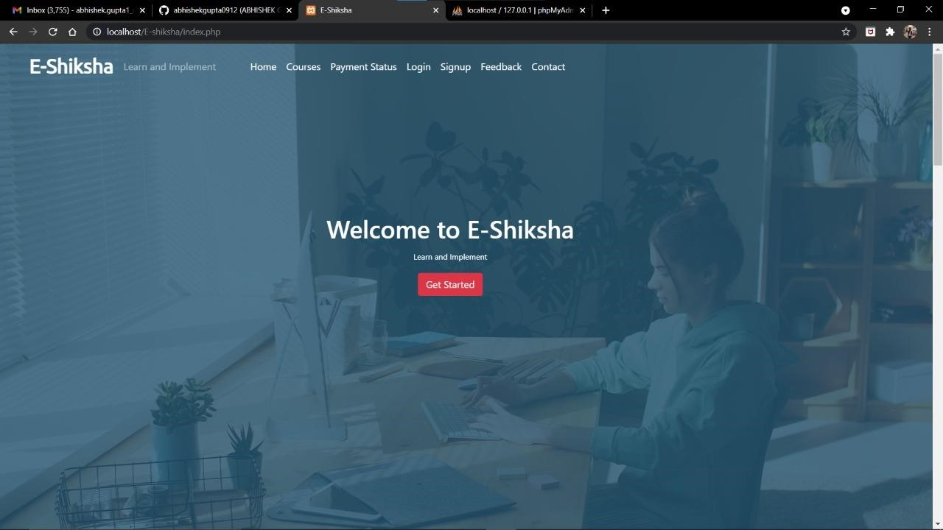

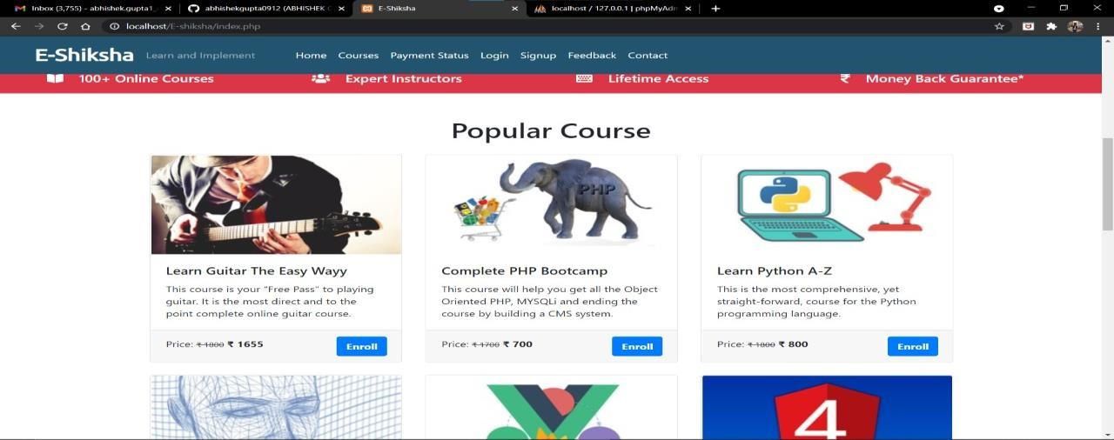

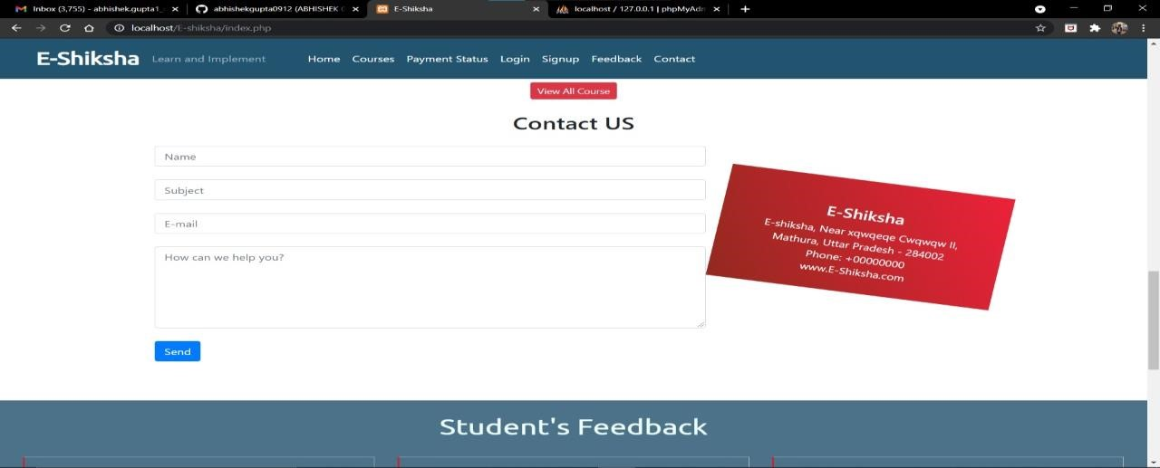

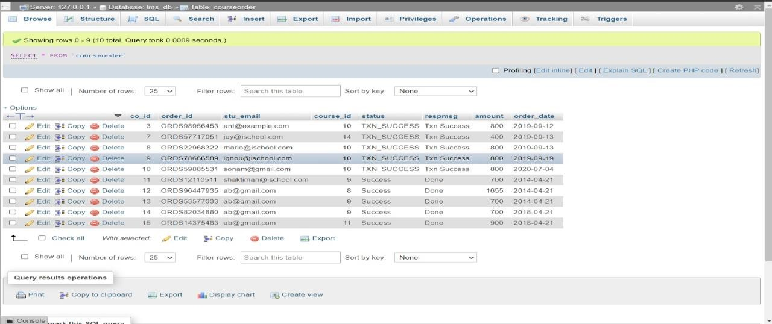

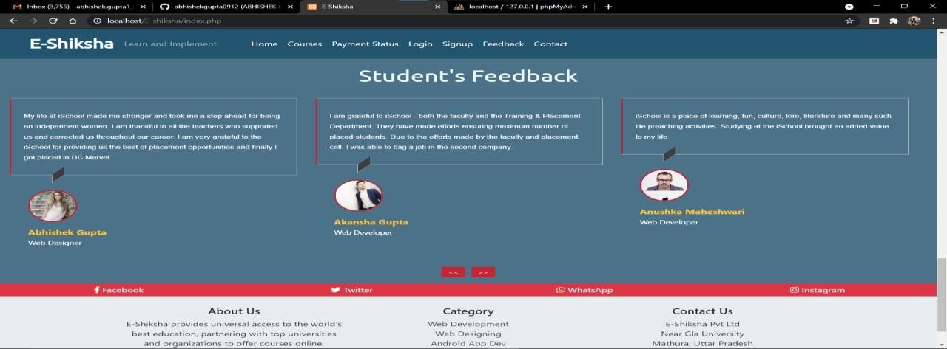

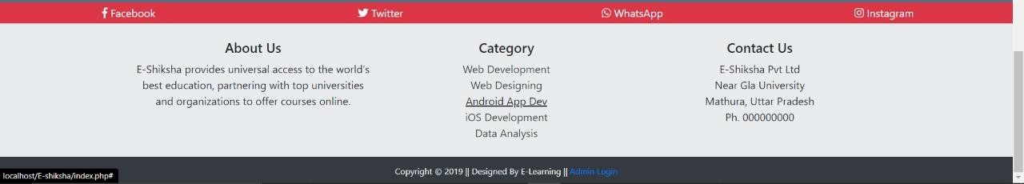

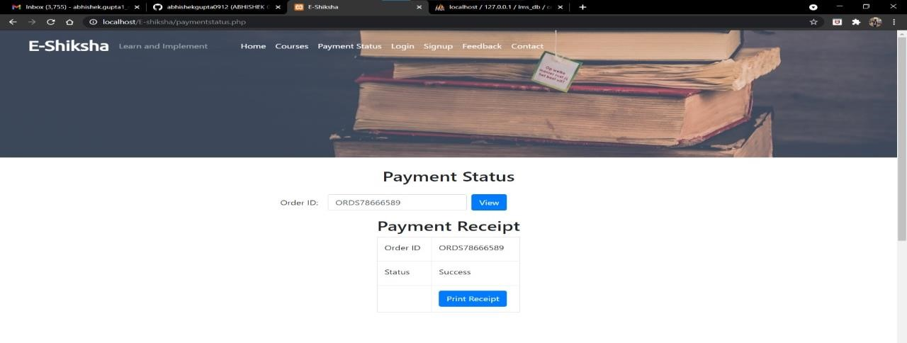

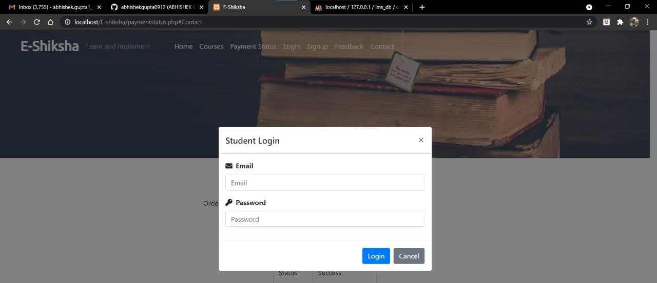

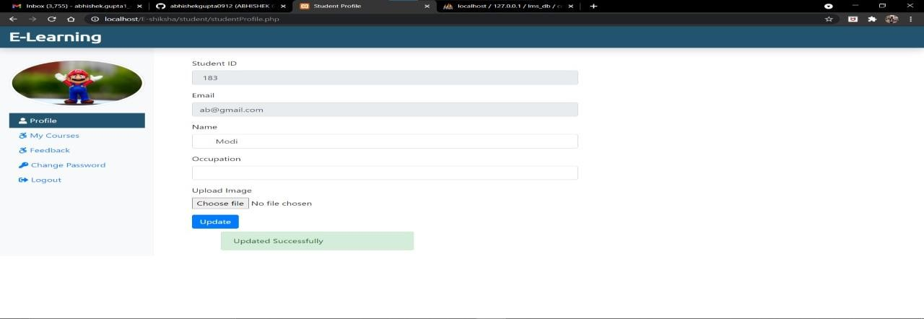

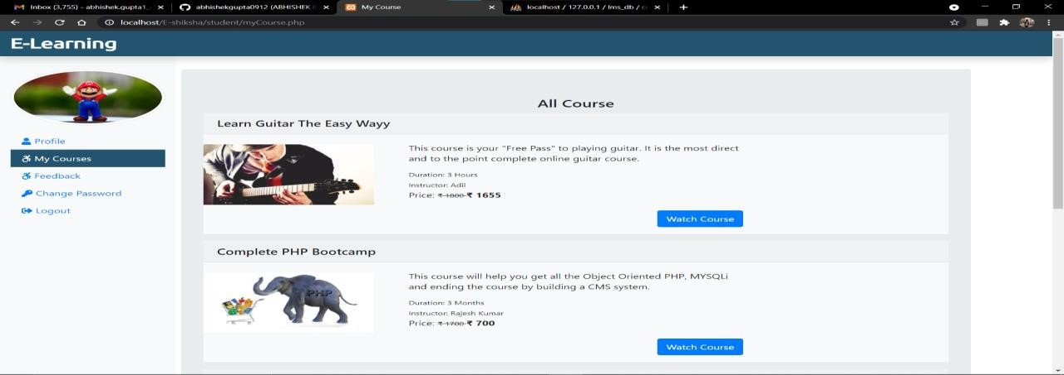

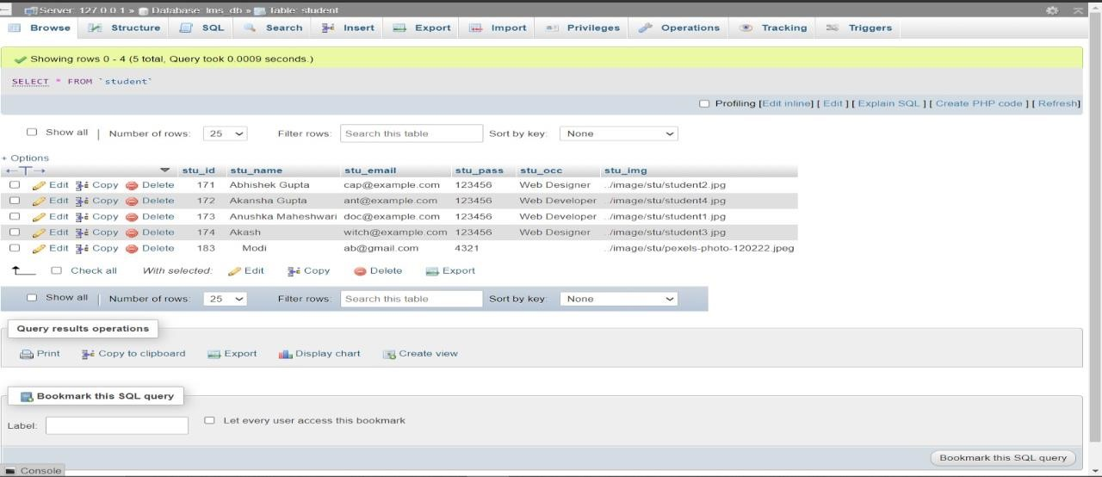

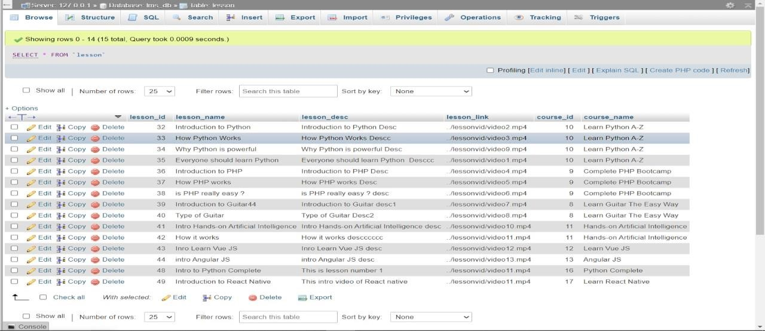

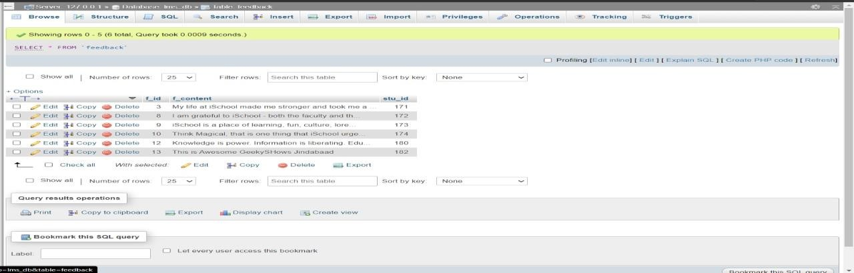



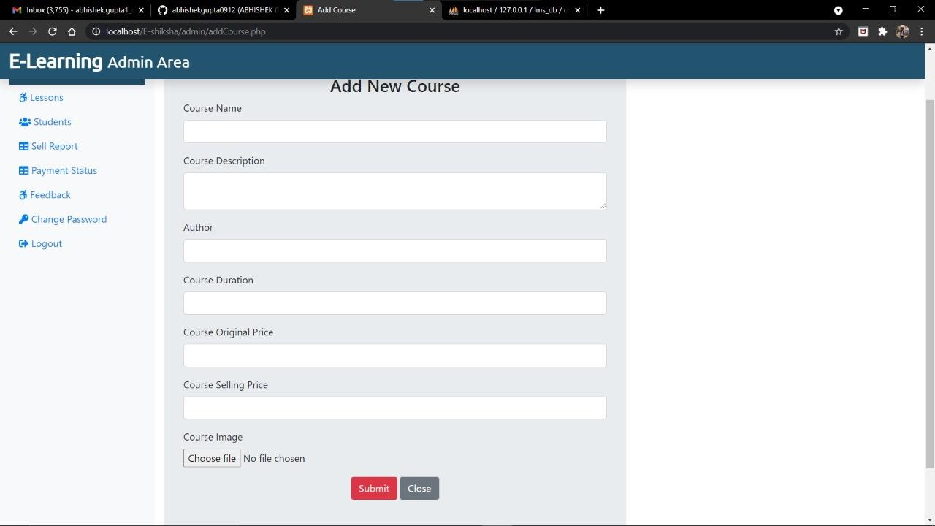

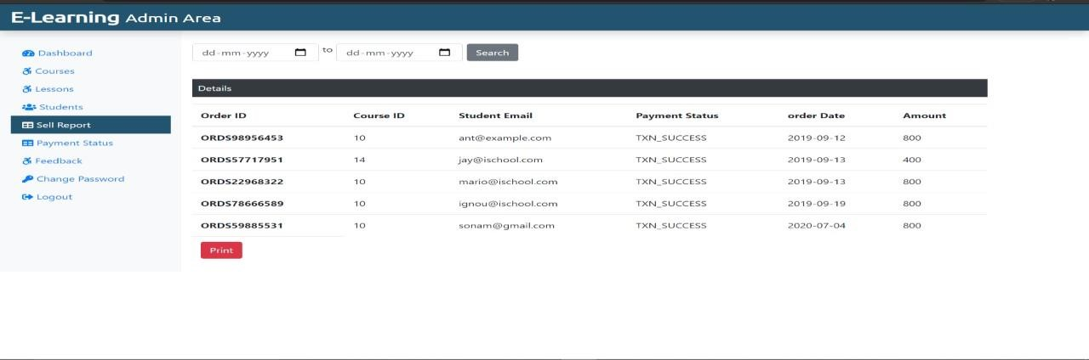

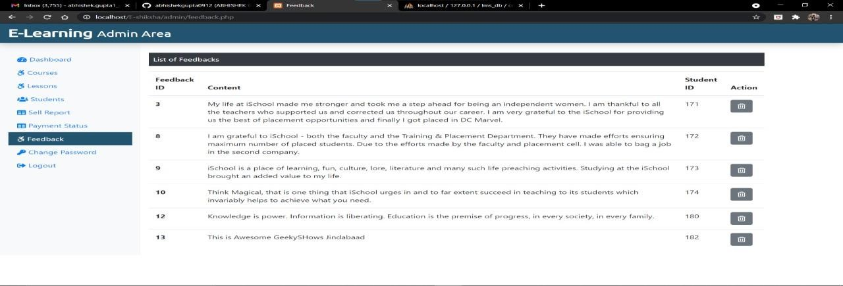

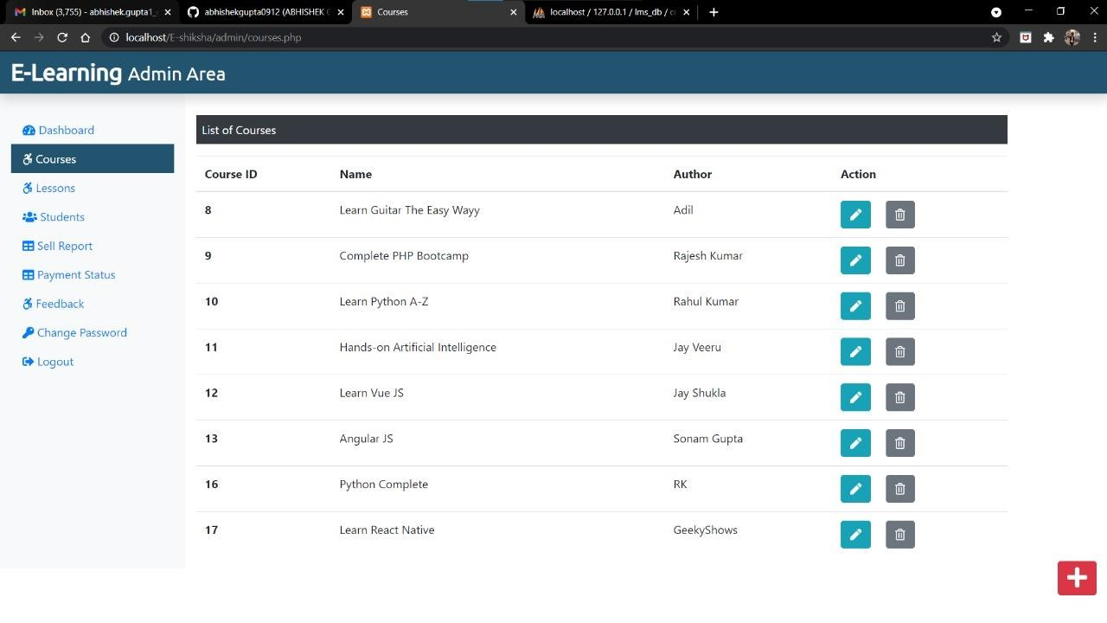

**CODE**

**Checkout.php**

|  |
| --- |
| <?php |
|  | include('./dbConnection.php'); |
|  | session_start(); |
|  | if(!isset($_SESSION['stuLogEmail'])) { |
|  | echo "<script> location.href='loginorsignup.php'; </script>"; |
|  | } else { |
|  | $stuEmail = $_SESSION['stuLogEmail']; |
|  | ?> |
|  | <!DOCTYPE html> |
|  | <html lang="en"> |
|  | <head> |
|  | <meta charset="UTF-8"> |
|  | <meta name="viewport" content="width=device-width, initial-scale=1.0"> |
|  | <meta http-equiv="X-UA-Compatible" content="ie=edge"> |
|  | <!-- Bootstrap CSS --> |
|  | <link rel="stylesheet" type="text/css" href="css/bootstrap.min.css"> |
|  |  |
|  | <!-- Font Awesome CSS --> |
|  | <link rel="stylesheet" type="text/css" href="css/all.min.css"> |
|  |  |
|  | <!-- Google Font --> |
|  | <link href="https://fonts.googleapis.com/css?family=Ubuntu" rel="stylesheet"> |
|  |  |
|  | <!-- Custom Style CSS --> |
|  | <link rel="stylesheet" type="text/css" href="./css/style.css" /> |
|  |  |
|  | <title>Checkout</title> |
|  | </head> |
|  | <body> |
|  | <div class="container mt-5"> |
|  | <div class="row"> |
|  | <div class="col-sm-6 offset-sm-3 jumbotron"> |
|  | <h3 class="mb-5">Welcome to E-Learning Payment Page</h3> |
|  | <form method="post" action="./paymentdone.php"> |
|  | <div class="form-group row"> |
|  | <label for="ORDER_ID" class="col-sm-4 col-form-label">Order ID</label> |
|  | <div class="col-sm-8"> |
|  | <input id="ORDER_ID" class="form-control" tabindex="1" maxlength="20" size="20" name="ORDER_ID" autocomplete="off" |
|  | value="<?php echo "ORDS" . rand(10000,99999999)?>" readonly> |
|  | </div> |
|  | </div> |
|  | <div class="form-group row"> |
|  | <label for="CUST_ID" class="col-sm-4 col-form-label">Student Email</label> |
|  | <div class="col-sm-8"> |
|  | <input id="CUST_ID" class="form-control" tabindex="2" maxlength="12" size="12" name="CUST_ID" autocomplete="off" value="<?php if(isset($stuEmail)){echo $stuEmail; }?>" readonly> |
|  | </div> |
|  | </div> |
|  | <div class="form-group row"> |
|  | <label for="TXN_AMOUNT" class="col-sm-4 col-form-label">Amount</label> |
|  | <div class="col-sm-8"> |
|  | <input title="TXN_AMOUNT" class="form-control" tabindex="10" |
|  | type="text" name="TXN_AMOUNT" value="<?php if(isset($_POST['id'])){echo $_POST['id']; }?>" readonly> |
|  | </div> |
|  | </div> |
|  | <div class="text-center"> |
|  | <input value="Check out" type="submit" class="btn btn-primary" onclick=""> |
|  | <a href="./courses.php" class="btn btn-secondary">Cancel</a> |
|  | </div> |
|  | </form> |
|  | <small class="form-text text-muted">Note: Complete Payment by Clicking Checkout Button</small> |
|  | </div> |
|  | </div> |
|  | </div> |
|  |  |
|  | <!-- Jquery and Boostrap JavaScript --> |
|  | <script type="text/javascript" src="js/jquery.min.js"></script> |
|  | <script type="text/javascript" src="js/popper.min.js"></script> |
|  | <script type="text/javascript" src="js/bootstrap.min.js"></script> |
|  |  |
|  | <!-- Font Awesome JS --> |
|  | <script type="text/javascript" src="js/all.min.js"></script> |
|  |  |
|  | <!-- Custom JavaScript --> |
|  | <script type="text/javascript" src="js/custom.js"></script> |
|  |  |
|  | </body> |
|  | </html> |
|  | <?php } ?> |

Contact.php

|  |
| --- |
|  |
|  | <div class="container mt-4" id="Contact"> <!--Start Contact Us Container--> |
|  | <h2 class="text-center mb-4">Contact US</h2> <!-- Contact Us Heading --> |
|  | <div class="row"> <!--Start Contact Us Row--> |
|  | <div class="col-md-8"> <!--Start Contact Us 1st Column--> |
|  | <form action="" method="post"> |
|  | <input type="text" class="form-control" name="name" placeholder="Name"><br> |
|  | <input type="text" class="form-control" name="subject" placeholder="Subject"><br> |
|  | <input type="email" class="form-control" name="email" placeholder="E-mail"><br> |
|  | <textarea class="form-control" name="message" placeholder="How can we help you?" style="height:150px;"></textarea><br> |
|  | <input class="btn btn-primary" type="submit" value="Send" name="submit"><br><br> |
|  | </form> |
|  | </div> <!-- End Contact Us 1st Column--> |
|  |  |
|  | <div class="col-md-4 stripe text-white text-center"> <!-- Start Contact Us 2nd Column--> |
|  | <h4>E-Shiksha</h4> |
|  | <p>E-shiksha, |
|  | Near xqwqeqe Cwqwqw II, Mathura, |
|  | Uttar Pradesh - 284002<br /> |
|  | Phone: +00000000 <br /> |
|  | www.E-Shiksha.com </p> |
|  | </div> <!-- End Contact Us 2nd Column--> |
|  | </div> <!-- End Contact Us Row--> |
|  | </div> <!-- End Contact Us Container--> |
|  |  |

Contactdetails.php

|  |
| --- |
| <?php |
|  | include('./dbConnection.php'); |
|  | // Header Include from mainInclude |
|  | include('./mainInclude/header.php'); |
|  | ?> |
|  | <div class="container-fluid bg-dark"> <!-- Start Course Page Banner --> |
|  | <div class="row"> |
|  | <img src="./image/coursebanner.jpg" alt="courses" style="height:200px; width:100%; object-fit:cover; box-shadow:10px;"/> |
|  | </div> |
|  | </div> <!-- End Course Page Banner --> |
|  |  |
|  | <div class="container mt-5"> <!-- Start All Course --> |
|  | <?php |
|  | if(isset($_GET['course_id'])){ |
|  | $course_id = $_GET['course_id']; |
|  | $_SESSION['course_id'] = $course_id; |
|  | $sql = "SELECT * FROM course WHERE course_id = '$course_id'"; |
|  | $result = $conn->query($sql); |
|  | if($result->num_rows > 0){ |
|  | while($row = $result->fetch_assoc()){ |
|  | echo ' |
|  | <div class="row"> |
|  | <div class="col-md-4"> |
|  | <img src="'.str_replace('..', '.', $row['course_img']).'" class="card-img-top" alt="Guitar" /> |
|  | </div> |
|  | <div class="col-md-8"> |
|  | <div class="card-body"> |
|  | <h5 class="card-title">Course Name: '.$row['course_name'].'</h5> |
|  | <p class="card-text"> Description: '.$row['course_desc'].'</p> |
|  | <p class="card-text"> Duration: '.$row['course_duration'].'</p> |
|  | <form action="checkout.php" method="post"> |
|  | <p class="card-text d-inline">Price: <small><del>&#8377 '.$row['course_original_price'].'</del></small> <span class="font-weight-bolder">&#8377 '.$row['course_price'].'<span></p> |
|  | <input type="hidden" name="id" value='. $row["course_price"] .'> |
|  | <button type="submit" class="btn btn-primary text-white font-weight-bolder float-right" name="buy">Buy Now</button> |
|  | </form> |
|  | </div> |
|  | </div> |
|  | '; |
|  | } |
|  | } |
|  | } |
|  | ?> |
|  | </div><!-- End All Course --> |
|  | <div class="container"> |
|  | <div class="row"> |
|  | <?php $sql = "SELECT * FROM lesson"; |
|  | $result = $conn->query($sql); |
|  | if($result->num_rows > 0){ |
|  | echo ' |
|  | <table class="table table-bordered table-hover"> |
|  | <thead> |
|  | <tr> |
|  | <th scope="col">Lesson No.</th> |
|  | <th scope="col">Lesson Name</th> |
|  | </tr> |
|  | </thead> |
|  | <tbody>'; |
|  | $num = 0; |
|  | while($row = $result->fetch_assoc()){ |
|  | if($row['course_id'] == $course_id) { |
|  | $num++; |
|  | echo ' <tr> |
|  | <th scope="row">'.$num.'</th> |
|  | <td>'. $row["lesson_name"].'</td></tr>'; |
|  | } |
|  | } |
|  | echo '</tbody> |
|  | </table>'; |
|  | } ?> |
|  | </div> |
|  | </div> |
|  | <?php |
|  | // Footer Include from mainInclude |
|  | include('./mainInclude/footer.php'); |
|  | ?> |

Courses.php

|  |
| --- |
| <?php |
|  | include('./dbConnection.php'); |
|  | // Header Include from mainInclude |
|  | include('./mainInclude/header.php'); |
|  | ?> |
|  | <div class="container-fluid bg-dark"> <!-- Start Course Page Banner --> |
|  | <div class="row"> |
|  | <img src="./image/coursebanner.jpg" alt="courses" style="height:500px; width:100%; object-fit:cover; box-shadow:10px;"/> |
|  | </div> |
|  | </div> <!-- End Course Page Banner --> |
|  |  |
|  | <div class="container mt-5"> <!-- Start All Course --> |
|  | <h1 class="text-center">All Courses</h1> |
|  | <div class="row mt-4"> <!-- Start All Course Row --> |
|  | <?php |
|  | $sql = "SELECT * FROM course"; |
|  | $result = $conn->query($sql); |
|  | if($result->num_rows > 0){ |
|  | while($row = $result->fetch_assoc()){ |
|  | $course_id = $row['course_id']; |
|  | echo ' |
|  | <div class="col-sm-4 mb-4"> |
|  | <a href="coursedetails.php?course_id='.$course_id.'" class="btn" style="text-align: left; padding:0px;"><div class="card"> |
|  | <img src="'.str_replace('..', '.', $row['course_img']).'" class="card-img-top" alt="Guitar" /> |
|  | <div class="card-body"> |
|  | <h5 class="card-title">'.$row['course_name'].'</h5> |
|  | <p class="card-text">'.$row['course_desc'].'</p> |
|  | </div> |
|  | <div class="card-footer"> |
|  | <p class="card-text d-inline">Price: <small><del>&#8377 '.$row['course_original_price'].'</del></small> <span class="font-weight-bolder">&#8377 '.$row['course_price'].'<span></p> <a class="btn btn-primary text-white font-weight-bolder float-right" href="coursedetails.php?course_id='.$course_id.'">Enroll</a> |
|  | </div> |
|  | </div> </a> |
|  | </div> |
|  | '; |
|  | } |
|  | } |
|  | ?> |
|  | </div><!-- End All Course Row --> |
|  | </div><!-- End All Course --> |
|  |  |
|  | <?php |
|  | // Contact Us |
|  | include('./contact.php'); |
|  | ?> |
|  |  |
|  | <?php |
|  | // Footer Include from mainInclude |
|  | include('./mainInclude/footer.php'); |
|  | ?> |

dbconnection.php

|  |
| --- |
| <?php |
|  | $db_host = "localhost"; |
|  | $db_user = "root"; |
|  | $db_password = ""; |
|  | $db_name = "lms_db"; |
|  |  |
|  | // Create Connection |
|  | $conn = new mysqli($db_host, $db_user, $db_password, $db_name); |
|  |  |
|  | // Check Connection |
|  | if($conn->connect_error) { |
|  | die("connection failed"); |
|  | } |
|  | // else { |
|  | // echo"connected"; |
|  | // } |
|  | ?> |

index.php

|  |
| --- |
| <?php |
|  | include('./dbConnection.php'); |
|  | // Header Include from mainInclude |
|  | include('./mainInclude/header.php'); |
|  | ?> |
|  | <!-- Start Video Background--> |
|  | <div class="container-fluid remove-vid-marg"> |
|  | <div class="vid-parent"> |
|  | <video playsinline autoplay muted loop> |
|  | <source src="video/123.mp4" /> |
|  | </video> |
|  | <div class="vid-overlay"></div> |
|  | </div> |
|  | <div class="vid-content" > |
|  | <h1 class="my-content">Welcome to E-Shiksha</h1> |
|  | <small class="my-content">Learn and Implement</small><br /> |
|  | <?php |
|  | if(!isset($_SESSION['is_login'])){ |
|  | echo '<a class="btn btn-danger mt-3" href="#" data-toggle="modal" data-target="#stuRegModalCenter">Get Started</a>'; |
|  | } else { |
|  | echo '<a class="btn btn-primary mt-3" href="student/studentProfile.php">My Profile</a>'; |
|  | } |
|  | ?> |
|  |  |
|  | </div> |
|  | </div> <!-- End Video Background --> |
|  |  |
|  | <div class="container-fluid bg-danger txt-banner"> <!-- Start Text Banner --> |
|  | <div class="row bottom-banner"> |
|  | <div class="col-sm"> |
|  | <h5> <i class="fas fa-book-open mr-3"></i> 100+ Online Courses</h5> |
|  | </div> |
|  | <div class="col-sm"> |
|  | <h5><i class="fas fa-users mr-3"></i> Expert Instructors</h5> |
|  | </div> |
|  | <div class="col-sm"> |
|  | <h5><i class="fas fa-keyboard mr-3"></i> Lifetime Access</h5> |
|  | </div> |
|  | <div class="col-sm"> |
|  | <h5><i class="fas fa-rupee-sign mr-3"></i> Money Back Guarantee*</h5> |
|  | </div> |
|  | </div> |
|  | </div> <!-- End Text Banner --> |
|  |  |
|  | <div class="container mt-5"> <!-- Start Most Popular Course --> |
|  | <h1 class="text-center">Popular Course</h1> |
|  | <div class="card-deck mt-4"> <!-- Start Most Popular Course 1st Card Deck --> |
|  | <?php |
|  | $sql = "SELECT * FROM course LIMIT 3"; |
|  | $result = $conn->query($sql); |
|  | if($result->num_rows > 0){ |
|  | while($row = $result->fetch_assoc()){ |
|  | $course_id = $row['course_id']; |
|  | echo ' |
|  | <a href="coursedetails.php?course_id='.$course_id.'" class="btn" style="text-align: left; padding:0px; margin:0px;"> |
|  | <div class="card"> |
|  | <img src="'.str_replace('..', '.', $row['course_img']).'" class="card-img-top" alt="Guitar" /> |
|  | <div class="card-body"> |
|  | <h5 class="card-title">'.$row['course_name'].'</h5> |
|  | <p class="card-text">'.$row['course_desc'].'</p> |
|  | </div> |
|  | <div class="card-footer"> |
|  | <p class="card-text d-inline">Price: <small><del>&#8377 '.$row['course_original_price'].'</del></small> <span class="font-weight-bolder">&#8377 '.$row['course_price'].'<span></p> <a class="btn btn-primary text-white font-weight-bolder float-right" href="coursedetails.php?course_id='.$course_id.'">Enroll</a> |
|  | </div> |
|  | </div> |
|  | </a> '; |
|  | } |
|  | } |
|  | ?> |
|  | </div> <!-- End Most Popular Course 1st Card Deck --> |
|  | <div class="card-deck mt-4"> <!-- Start Most Popular Course 2nd Card Deck --> |
|  | <?php |
|  | $sql = "SELECT * FROM course LIMIT 3,3"; |
|  | $result = $conn->query($sql); |
|  | if($result->num_rows > 0){ |
|  | while($row = $result->fetch_assoc()){ |
|  | $course_id = $row['course_id']; |
|  | echo ' |
|  | <a href="coursedetails.php?course_id='.$course_id.'" class="btn" style="text-align: left; padding:0px;"> |
|  | <div class="card"> |
|  | <img src="'.str_replace('..', '.', $row['course_img']).'" class="card-img-top" alt="Guitar" /> |
|  | <div class="card-body"> |
|  | <h5 class="card-title">'.$row['course_name'].'</h5> |
|  | <p class="card-text">'.$row['course_desc'].'</p> |
|  | </div> |
|  | <div class="card-footer"> |
|  | <p class="card-text d-inline">Price: <small><del>&#8377 '.$row['course_original_price'].'</del></small> <span class="font-weight-bolder">&#8377 '.$row['course_price'].'<span></p> <a class="btn btn-primary text-white font-weight-bolder float-right" href="#">Enroll</a> |
|  | </div> |
|  | </div> |
|  | </a> '; |
|  | } |
|  | } |
|  | ?> |
|  | </div> <!-- End Most Popular Course 2nd Card Deck --> |
|  | <div class="text-center m-2"> |
|  | <a class="btn btn-danger btn-sm" href="courses.php">View All Course</a> |
|  | </div> |
|  | </div> <!-- End Most Popular Course --> |
|  |  |
|  | <?php |
|  | // Contact Us |
|  | include('./contact.php'); |
|  | ?> |
|  |  |
|  | <!-- Start Students Testimonial --> |
|  | <div class="container-fluid mt-5" style="background-color: #4B7289" id="Feedback"> |
|  | <h1 class="text-center testyheading p-4"> Student's Feedback </h1> |
|  | <div class="row"> |
|  | <div class="col-md-12"> |
|  | <div id="testimonial-slider" class="owl-carousel"> |
|  | <?php |
|  | $sql = "SELECT s.stu_name, s.stu_occ, s.stu_img, f.f_content FROM student AS s JOIN feedback AS f ON s.stu_id = f.stu_id"; |
|  | $result = $conn->query($sql); |
|  | if($result->num_rows > 0) { |
|  | while($row = $result->fetch_assoc()){ |
|  | $s_img = $row['stu_img']; |
|  | $n_img = str_replace('../','',$s_img) |
|  | ?> |
|  | <div class="testimonial"> |
|  | <p class="description"> |
|  | <?php echo $row['f_content'];?> |
|  | </p> |
|  | <div class="pic"> |
|  | <img src="<?php echo $n_img; ?>" alt=""/> |
|  | </div> |
|  | <div class="testimonial-prof"> |
|  | <h4><?php echo $row['stu_name']; ?></h4> |
|  | <small><?php echo $row['stu_occ']; ?></small> |
|  | </div> |
|  | </div> |
|  | <?php }} ?> |
|  | </div> |
|  | </div> |
|  | </div> |
|  | </div> <!-- End Students Testimonial --> |
|  |  |
|  | <div class="container-fluid bg-danger"> <!-- Start Social Follow --> |
|  | <div class="row text-white text-center p-1"> |
|  | <div class="col-sm"> |
|  | <a class="text-white social-hover" href="#"><i class="fab fa-facebook-f"></i> Facebook</a> |
|  | </div> |
|  | <div class="col-sm"> |
|  | <a class="text-white social-hover" href="#"><i class="fab fa-twitter"></i> Twitter</a> |
|  | </div> |
|  | <div class="col-sm"> |
|  | <a class="text-white social-hover" href="#"><i class="fab fa-whatsapp"></i> WhatsApp</a> |
|  | </div> |
|  | <div class="col-sm"> |
|  | <a class="text-white social-hover" href="#"><i class="fab fa-instagram"></i> Instagram</a> |
|  | </div> |
|  | </div> |
|  | </div> <!-- End Social Follow --> |
|  |  |
|  | <!-- Start About Section --> |
|  | <div class="container-fluid p-4" style="background-color:#E9ECEF"> |
|  | <div class="container" style="background-color:#E9ECEF"> |
|  | <div class="row text-center"> |
|  | <div class="col-sm"> |
|  | <h5>About Us</h5> |
|  | <p>E-Shiksha provides universal access to the world’s best education, partnering with top universities and organizations to offer courses online.</p> |
|  | </div> |
|  | <div class="col-sm"> |
|  | <h5>Category</h5> |
|  | <a class="text-dark" href="#">Web Development</a><br /> |
|  | <a class="text-dark" href="#">Web Designing</a><br /> |
|  | <a class="text-dark" href="#">Android App Dev</a><br /> |
|  | <a class="text-dark" href="#">iOS Development</a><br /> |
|  | <a class="text-dark" href="#">Data Analysis</a><br /> |
|  | </div> |
|  | <div class="col-sm"> |
|  | <h5>Contact Us</h5> |
|  | <p>E-Shiksha Pvt Ltd <br> Near Gla University <br>Mathura, Uttar Pradesh <br> Ph. 000000000 </p> |
|  | </div> |
|  | </div> |
|  | </div> |
|  | </div> <!-- End About Section --> |
|  |  |
|  | <?php |
|  | // Footer Include from mainInclude |
|  | include('./mainInclude/footer.php'); |
|  |  |
|  | ?> |

loginorsignup.php

|  |
| --- |
| <?php |
|  | include('./dbConnection.php'); |
|  | // Header Include from mainInclude |
|  | include('./mainInclude/header.php'); |
|  | ?> |
|  | <div class="container-fluid bg-dark"> <!-- Start Course Page Banner --> |
|  | <div class="row"> |
|  | <img src="./image/coursebanner.jpg" alt="courses" style="height:300px; width:100%; object-fit:cover; box-shadow:10px;"/> |
|  | </div> |
|  | </div> <!-- End Course Page Banner --> |
|  |  |
|  |  |
|  | <div class="container jumbotron mb-5"> |
|  | <div class="row"> |
|  | <div class="col-md-4"> |
|  | <h5 class="mb-3">If Already Registered !! Login</h5> |
|  | <form role="form" id="stuLoginForm"> |
|  | <div class="form-group"> |
|  | <i class="fas fa-envelope"></i><label for="stuLogEmail" class="pl-2 font-weight-bold">Email</label><small id="statusLogMsg1"></small><input type="email" |
|  | class="form-control" placeholder="Email" name="stuLogEmail" id="stuLogEmail"> |
|  | </div> |
|  | <div class="form-group"> |
|  | <i class="fas fa-key"></i><label for="stuLogPass" class="pl-2 font-weight-bold">Password</label><input type="password" class="form-control" placeholder="Password" name="stuLogPass" id="stuLogPass"> |
|  | </div> |
|  | <button type="button" class="btn btn-primary" id="stuLoginBtn" onclick="checkStuLogin()">Login</button> |
|  | </form><br/> |
|  | <small id="statusLogMsg"></small> |
|  | </div> |
|  | <div class="col-md-6 offset-md-1"> |
|  | <h5 class="mb-3">New User !! Sign Up</h5> |
|  | <form role="form" id="stuRegForm"> |
|  | <div class="form-group"> |
|  | <i class="fas fa-user"></i><label for="stuname" class="pl-2 font-weight-bold">Name</label><small id="statusMsg1"></small><input type="text" |
|  | class="form-control" placeholder="Name" name="stuname" id="stuname"> |
|  | </div> |
|  | <div class="form-group"> |
|  | <i class="fas fa-envelope"></i><label for="stuemail" class="pl-2 font-weight-bold">Email</label><small id="statusMsg2"></small><input type="email" |
|  | class="form-control" placeholder="Email" name="stuemail" id="stuemail"> |
|  | <small class="form-text">We'll never share your email with anyone else.</small> |
|  | </div> |
|  | <div class="form-group"> |
|  | <i class="fas fa-key"></i><label for="stupass" class="pl-2 font-weight-bold">New |
|  | Password</label><small id="statusMsg3"></small><input type="password" class="form-control" placeholder="Password" name="stupass" id="stupass"> |
|  | </div> |
|  | <button type="button" class="btn btn-primary" id="signup" onclick="addStu()">Sign Up</button> |
|  | </form> <br/> |
|  | <small id="successMsg"></small> |
|  | </div> |
|  | </div> |
|  | </div> |
|  | <hr/> |
|  |  |
|  | <?php |
|  | // Contact Us |
|  | include('./contact.php'); |
|  | ?> |
|  |  |
|  | <?php |
|  | // Footer Include from mainInclude |
|  | include('./mainInclude/footer.php'); |
|  | ?> |

logout.php

|  |
| --- |
| <?php |
|  | session_start(); |
|  | session_destroy(); |
|  | echo "<script> location.href='index.php'; </script>"; |
|  | ?> |

pagenotfound.php

|  |
| --- |
| !DOCTYPE html> |
|  | <html lang="en"> |
|  | <head> |
|  | <meta charset="UTF-8"> |
|  | <meta name="viewport" content="width=device-width, initial-scale=1.0"> |
|  | <meta http-equiv="X-UA-Compatible" content="ie=edge"> |
|  | <title>Error 404</title> |
|  | </head> |
|  | <body> |
|  | <h2>error 404: Page Not Found !!</h2> |
|  | </body> |
|  | </html> |

paymentdone.php

|  |
| --- |
| <?php |
|  | include('./dbConnection.php'); |
|  | session_start(); |
|  | if(!isset($_SESSION['stuLogEmail'])) { |
|  | echo "<script> location.href='loginorsignup.php'; </script>"; |
|  | } else { |
|  | date_default_timezone_set('Asia/Kolkata'); |
|  | $date = date('d-m-y h:i:s'); |
|  | if(isset($_POST['ORDER_ID']) && isset($_POST['TXN_AMOUNT'])){ |
|  | $order_id = $_POST['ORDER_ID']; |
|  | $stu_email = $_SESSION['stuLogEmail']; |
|  | $course_id = $_SESSION['course_id']; |
|  | $status = "Success"; |
|  | $respmsg = "Done"; |
|  | $amount = $_POST['TXN_AMOUNT']; |
|  | $date = $date; |
|  | $sql = "INSERT INTO courseorder(order_id, stu_email, course_id, status, respmsg, amount, order_date) VALUES ('$order_id', '$stu_email', '$course_id', '$status', '$respmsg', '$amount', '$date')"; |
|  | if($conn->query($sql) == TRUE){ |
|  | echo "Redirecting to My Profile...."; |
|  | echo "<script> setTimeout(() => { |
|  | window.location.href = './Student/myCourse.php'; |
|  | }, 1500); </script>"; |
|  | }; |
|  | } else { |
|  | echo "<b>Transaction status is failure</b>" . "<br/>"; |
|  | } |
|  | } |
|  | ?> |

paymentstatus.php

|  |
| --- |
| <?php |
|  | include('./dbConnection.php'); |
|  | // Header Include from mainInclude |
|  | include('./mainInclude/header.php'); |
|  |  |
|  | $ORDER_ID = ""; |
|  |  |
|  | if (isset($_POST["ORDER_ID"]) && $_POST["ORDER_ID"] != "") { |
|  | $ORDER_ID = $_POST["ORDER_ID"]; |
|  | } |
|  |  |
|  | ?> |
|  | <div class="container-fluid bg-dark"> <!-- Start Course Page Banner --> |
|  | <div class="row"> |
|  | <img src="./image/coursebanner.jpg" alt="courses" style="height:300px; width:100%; object-fit:cover; box-shadow:10px;"/> |
|  | </div> |
|  | </div> <!-- End Course Page Banner --> |
|  | <div class="container"> |
|  | <h2 class="text-center my-4">Payment Status </h2> |
|  | <form method="post" action=""> |
|  | <div class="form-group row"> |
|  | <label class="offset-sm-3 col-form-label">Order ID: </label> |
|  | <div> |
|  | <input class="form-control mx-3" id="ORDER_ID" tabindex="1" maxlength="20" size="20" name="ORDER_ID" autocomplete="off" value="<?php echo $ORDER_ID ?>"> |
|  | </div> |
|  | <div> |
|  | <input class="btn btn-primary mx-4" value="View" type="submit" onclick=""> |
|  | </div> |
|  | </div> |
|  | </form> |
|  | </div> |
|  | <div class="container"> |
|  | <?php |
|  | if (isset($_POST['ORDER_ID'])) |
|  | { |
|  | $sql = "SELECT order_id FROM courseorder"; |
|  | $result = $conn->query($sql); |
|  | while($row = $result->fetch_assoc()){ |
|  | if($_POST["ORDER_ID"] == $row["order_id"]){ ?> |
|  | <div class="row justify-content-center"> |
|  | <div class="col-auto"> |
|  | <h2 class="text-center">Payment Receipt</h2> |
|  | <table class="table table-bordered"> |
|  | <tbody> |
|  | <tr > |
|  | <td><label>Order ID</label></td> |
|  | <td><?php if (isset($row["order_id"])) echo $row["order_id"] ?></td> |
|  | </tr> |
|  | <tr > |
|  | <td><label>Status</label></td> |
|  | <td>Success</td> |
|  | </tr> |
|  | <tr> |
|  | <td></td> |
|  | <td><button class="btn btn-primary" onclick="javascript:window.print();">Print Receipt</button></td> |
|  | </tr> |
|  | </tbody> |
|  | </table> |
|  | </div> |
|  | </div> |
|  | <?php |
|  | } } } ?> |
|  |  |
|  | </div> |
|  | <div class="mt-5"> |
|  | <?php |
|  | // Contact Us |
|  | include('./contact.php'); |
|  | ?> |
|  | </div> |
|  |  |
|  | <?php |
|  | // Footer Include from mainInclude |
|  | include('./mainInclude/footer.php'); |
|  | ?> |

studentRegistrartion.php

|  |
| --- |
| form role="form" id="stuRegForm"> |
|  | <div class="form-group"> |
|  | <i class="fas fa-user"></i><label for="stuname" class="pl-2 font-weight-bold">Name</label><small id="statusMsg1"></small><input type="text" |
|  | class="form-control" placeholder="Name" name="stuname" id="stuname"> |
|  | </div> |
|  | <div class="form-group"> |
|  | <i class="fas fa-envelope"></i><label for="stuemail" class="pl-2 font-weight-bold">Email</label><small id="statusMsg2"></small><input type="email" |
|  | class="form-control" placeholder="Email" name="stuemail" id="stuemail"> |
|  | <small class="form-text">We'll never share your email with anyone else.</small> |
|  | </div> |
|  | <div class="form-group"> |
|  | <i class="fas fa-key"></i><label for="stupass" class="pl-2 font-weight-bold">New |
|  | Password</label><small id="statusMsg3"></small><input type="password" class="form-control" placeholder="Password" name="stupass" id="stupass"> |
|  | </div> |
|  | </form> |

**CSS**

**Style.css**

|  |
| --- |
| .navbar-brand { |
|  | font-family: "Ubuntu", sans-serif; |
|  | font-size: 2em; |
|  | font-weight: bold; |
|  | color: #fff; |
|  | } |
|  |  |
|  | .custom-nav .custom-nav-item a { |
|  | color: #fff !important; |
|  | } |
|  |  |
|  | .custom-nav-item:hover { |
|  | background-color: #dc3545; |
|  | border: solid #dc3545 1px; |
|  | border-radius: 10px; |
|  | } |
|  |  |
|  | .remove-vid-marg { |
|  | margin: 0px; |
|  | padding: 0px; |
|  | } |
|  |  |
|  | .vid-parent { |
|  | position: relative; |
|  | } |
|  | video { |
|  | width: 100%; |
|  | height: 100%; |
|  | } |
|  | .vid-overlay { |
|  | position: absolute; |
|  | top: 0; |
|  | left: 0; |
|  | height: 100%; |
|  | width: 100%; |
|  | background-color: #225470; |
|  | z-index: 1; |
|  | opacity: 0.8; |
|  | } |
|  |  |
|  | .vid-content { |
|  | color: #fff; |
|  | position: absolute; |
|  | top: 35%; |
|  | left: 35%; |
|  | z-index: 2; |
|  | text-align: center; |
|  | } |
|  |  |
|  | .bottom-banner { |
|  | color: #fff; |
|  | padding: 10px; |
|  | } |
|  |  |
|  | .bottom-banner:first-child { |
|  | padding-left: 50px; |
|  | } |
|  |  |
|  | a.social-hover:hover { |
|  | padding: 5px 100px; |
|  | text-decoration: none; |
|  | background-color: rgb(95, 93, 93); |
|  | } |
|  |  |
|  | .stripe { |
|  | background-image: linear-gradient(240deg, #ed213a, #93291e); |
|  | padding: 3rem; |
|  | height: 13rem; |
|  | margin-top: 4rem; |
|  | transform: rotate(10deg); |
|  | z-index: -5; |
|  | } |
|  |  |
|  | @media screen and (min-width: 0px) and (max-width: 700px) { |
|  | .my-content, |
|  | .txt-banner, |
|  | .stripe { |
|  | display: none; |
|  | } /* hide it on small screens */ |
|  |  |
|  | .vid-content { |
|  | top: 12%; |
|  | left: 60%; |
|  | } |
|  | .custom-nav .custom-nav-item a { |
|  | padding: 10px 20px; |
|  | background-color: #225470; |
|  | } |
|  |  |
|  | .custom-nav-item:hover { |
|  | background-color: none; |
|  | border: none; |
|  | border-radius: none; |
|  | } |
|  | } |

**adminstyle.css**

|  |
| --- |
| .navbar-brand { |
|  | font-family: "Ubuntu", sans-serif; |
|  | font-size: 2em; |
|  | font-weight: bold; |
|  | color: #fff; |
|  | } |
|  |  |
|  | .active { |
|  | background-color: #225470; |
|  | color: #fff; |
|  | } |
|  |  |
|  | /* Plus Button for adding New Users Bottom Right */ |
|  | .box { |
|  | position: fixed; |
|  | bottom: 10px; |
|  | right: 20px; |
|  | margin-bottom: 30px; |
|  | } |

**Owl.min.css**

|  |
| --- |
| .owl-carousel .owl-wrapper:after { |
|  | content: "."; |
|  | display: block; |
|  | clear: both; |
|  | visibility: hidden; |
|  | line-height: 0; |
|  | height: 0; |
|  | } |
|  | .owl-carousel { |
|  | display: none; |
|  | position: relative; |
|  | width: 100%; |
|  | -ms-touch-action: pan-y; |
|  | } |
|  | .owl-carousel .owl-wrapper { |
|  | display: none; |
|  | position: relative; |
|  | -webkit-transform: translate3d(0, 0, 0); |
|  | } |
|  | .owl-carousel .owl-wrapper-outer { |
|  | overflow: hidden; |
|  | position: relative; |
|  | width: 100%; |
|  | } |
|  | .owl-carousel .owl-wrapper-outer.autoHeight { |
|  | -webkit-transition: height 500ms ease-in-out; |
|  | -moz-transition: height 500ms ease-in-out; |
|  | -ms-transition: height 500ms ease-in-out; |
|  | -o-transition: height 500ms ease-in-out; |
|  | transition: height 500ms ease-in-out; |
|  | } |
|  | .owl-carousel .owl-item { |
|  | float: left; |
|  | } |
|  | .owl-controls .owl-page, |
|  | .owl-controls .owl-buttons div { |
|  | cursor: pointer; |
|  | } |
|  | .owl-controls { |
|  | -webkit-user-select: none; |
|  | -khtml-user-select: none; |
|  | -moz-user-select: none; |
|  | -ms-user-select: none; |
|  | user-select: none; |
|  | -webkit-tap-highlight-color: rgba(0, 0, 0, 0); |
|  | } |
|  | .grabbing { |
|  | cursor: url(grabbing.png) 8 8, move; |
|  | } |
|  | .owl-carousel .owl-wrapper, |
|  | .owl-carousel .owl-item { |
|  | -webkit-backface-visibility: hidden; |
|  | -moz-backface-visibility: hidden; |
|  | -ms-backface-visibility: hidden; |
|  | -webkit-transform: translate3d(0, 0, 0); |
|  | -moz-transform: translate3d(0, 0, 0); |
|  | -ms-transform: translate3d(0, 0, 0); |
|  | } |

**Limitations of the Project**

* Only one tutor can access at a time
* It’s not SEO friendly
* Risk unauthorized accessibility
* Support is good in modern web browsers but not in legacy ones

**Future Scope of the Project**

* More than one tutor can be added
* Interaction between Student and Tutor can be improved by introducing Discussion forum
* Quiz Facility may enhance this application’s market value
* Live Class can be added

**Bibliography Books:**

▪ IGNOU Blocks of Systems Analysis and Design

▪ IGNOU Blocks of Introduction to Software Engineering

▪ The Complete Reference PHP

▪ Head First SQL: Your Brain on SQL by Lynn Beighley

**Web Source:**

▪ [www.google.co.in](http://www.google.co.in/)

▪ [www.wikipedia.org](http://www.wikipedia.org/)

▪ [www.php.net](http://www.php.net/)

▪ [www.stackoverflow.com](http://www.stackoverflow.com/)

▪ [www.getbootstrap.com](http://www.getbootstrap.com/)